**CSA1054-SOFTWARE ENGINEERING**

**LAB EXPERIMENTS**

**Name: K.R.Chandana**

**Register no:192211987**

**Experiment 1:** Draw a use case diagram to model for Online Voting System. A web-based voting system that will help to manage elections easily and securely, the voter should be able to successfully cast his vote or it should be a failure. There should be no intermediate state. In case of failures the voter should be allowed to retry immediately. The voting data should be consistent throughout the system. If we are replicating the data, we do not want any scenario where one database shows Voter-1 has voted Candidate-1 and another database has an old entry for Voter-1 showing he has voted for Candidate-2. We should always have strong consistency.

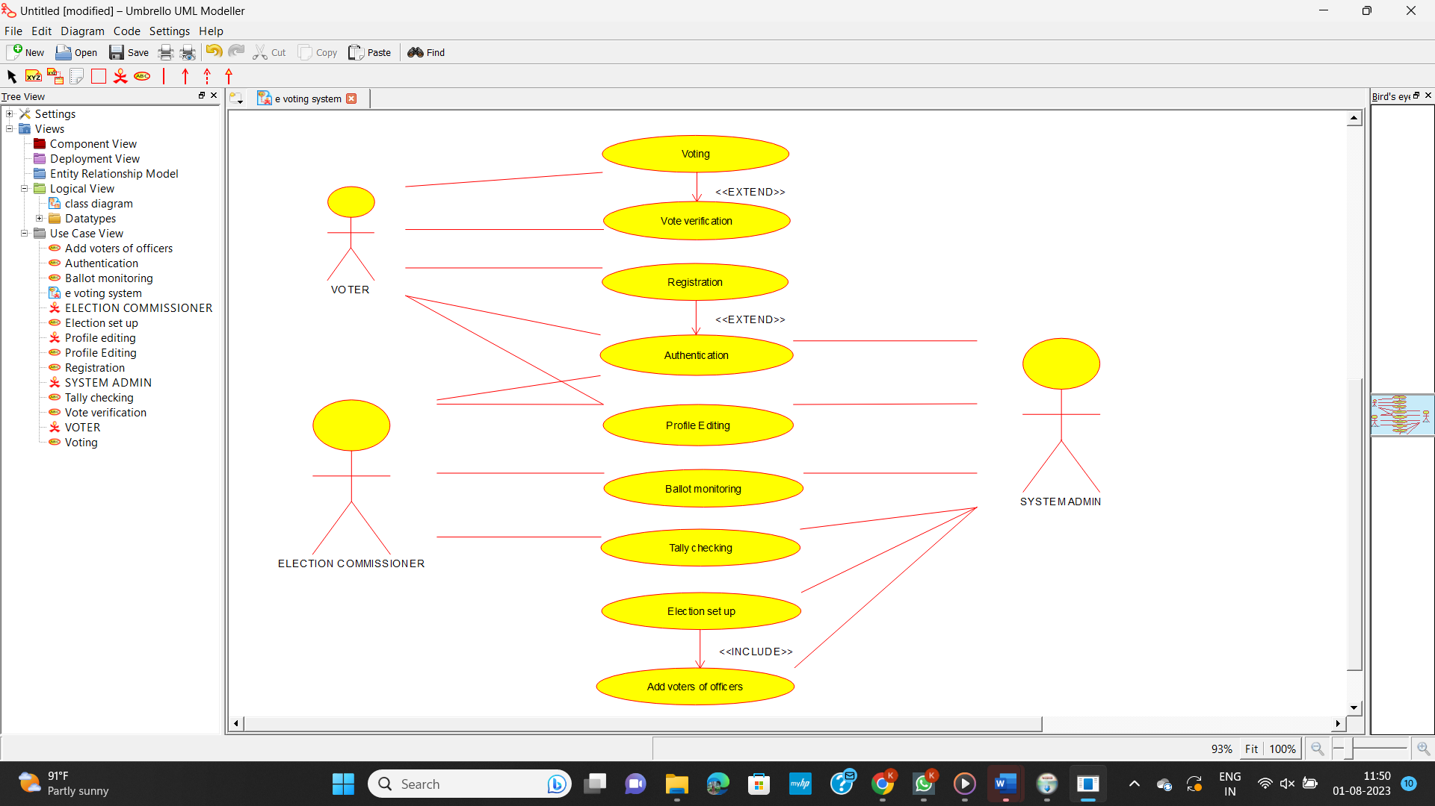

**Experiment 2:** Draw a use case diagram for Library Management System is an automation system used to manage a library and the different resource management required in it like cataloguing of books, allowing check out and return of books, invoicing, user management, etc. The user can search for book details using a few book properties (Book ID, Title, Author, and Publisher). Searching should return details about all the book copies that match the search query.

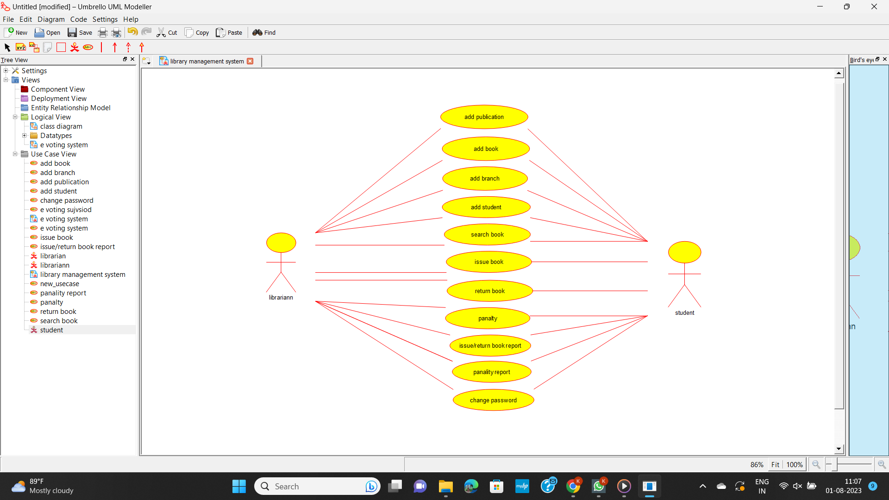

**Experiment 3:** Draw the use case diagram is a graphic depiction of the interactions among the elements of the Railway reservation system for maintaining admin user can search ticket, view the description of a selected ticket, add a ticket, update a ticket and delete a ticket and it shows the activity flow of editing, adding and updating of the customer. The user will be able to search and generate reports of payment, Booking and train schedules.

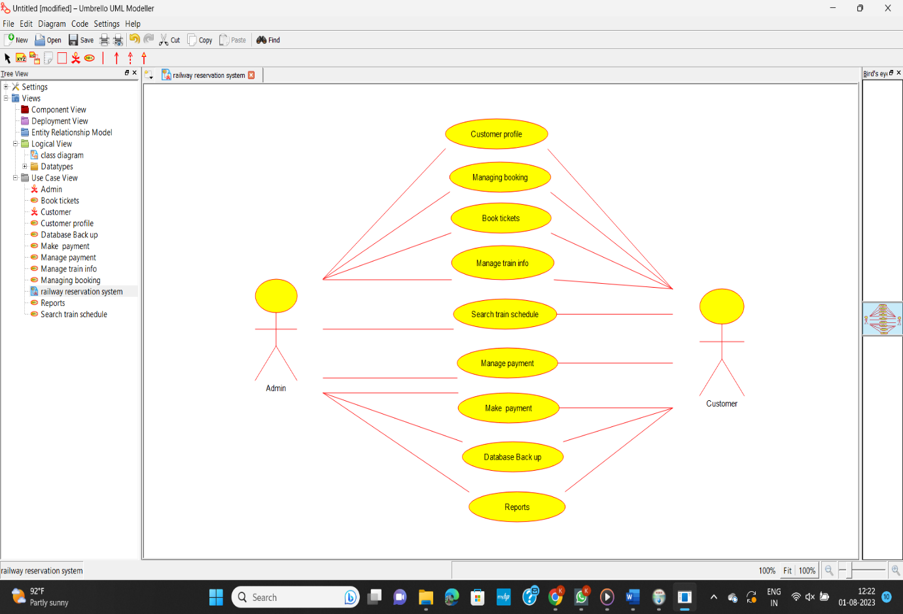

**Experiment 4:** Draw a USE-CASE diagram for the Hospital Management System. The activities of the hospital system are listed below. Receive the patient id, Patient name, pharmacy, laboratory, doctor, administrator, record officer, test report, drug management, test management, user management, dispense drug using CASE tools.

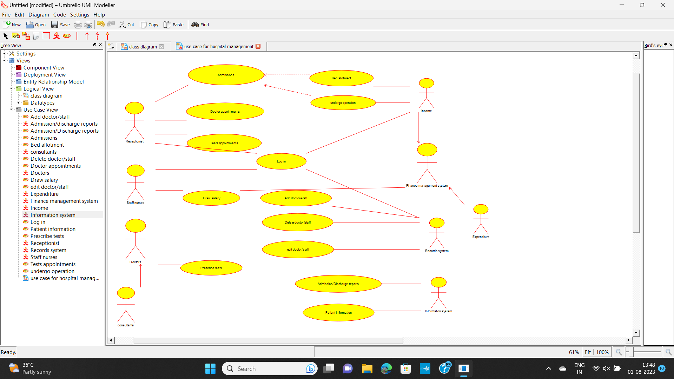

**Experiment 5:** Draw a USE-CASE diagram for an ATM System using CASE tool. The banking system allows a customer to access the financial transactions by ATM System; it has a step by step process describing the work of this process and elaborates what work can be done by customer, banking system, administrator and technicians with the ATM system.

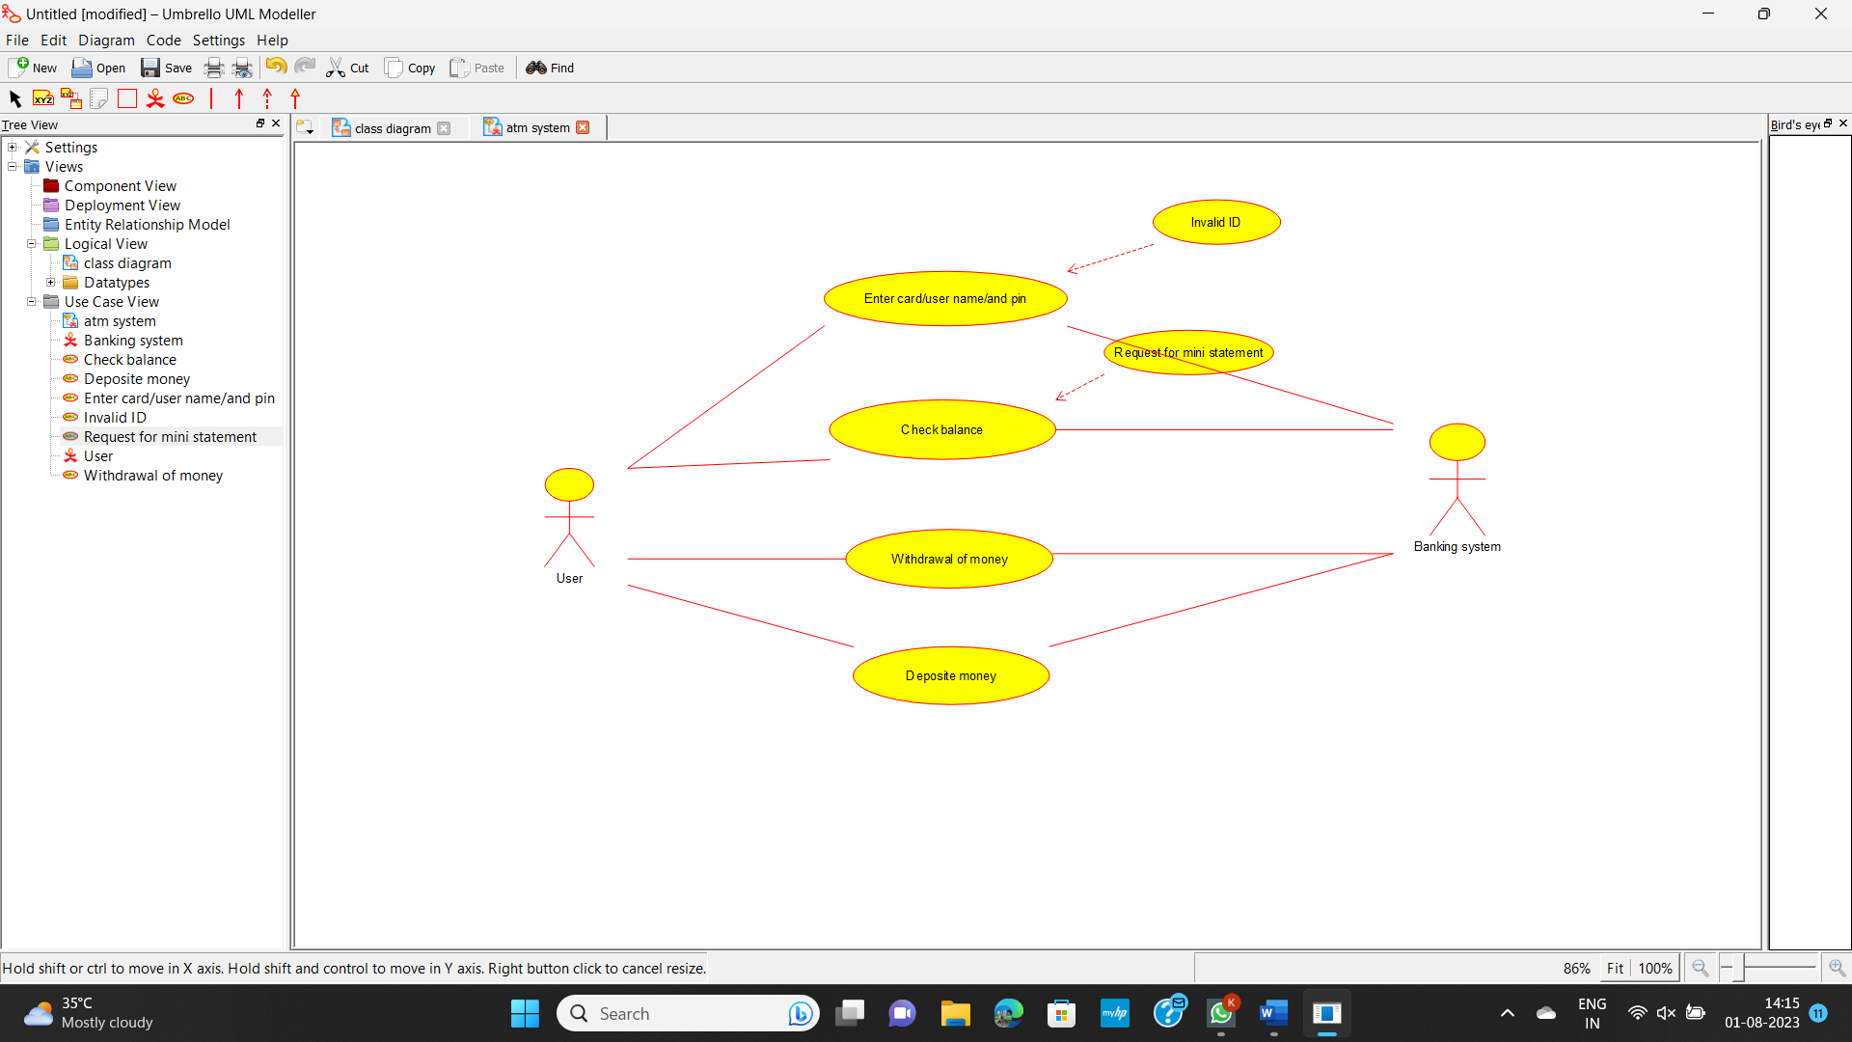

**Experiment 6:** Draw a USE-CASE diagram for Online college management System Manage student’s information and status, manage courses and subjects, Manage Instructors and designation, record all transactions Draw a USE-CASE diagram for Online Airline Management System which is a dedicated and highly configurable system for all airlines, which can be easily accessed by all users. It helps the users to book flights without visiting offline booking counters. This system can be accessible by any user from any location at any time. In such a system, a passenger should be able to view the availability of flights’ details, as per their requirement. They can book the flights online and can also cancel the reservation. The administrator manages the passenger booking system and updates the reservation status using CASE tools.

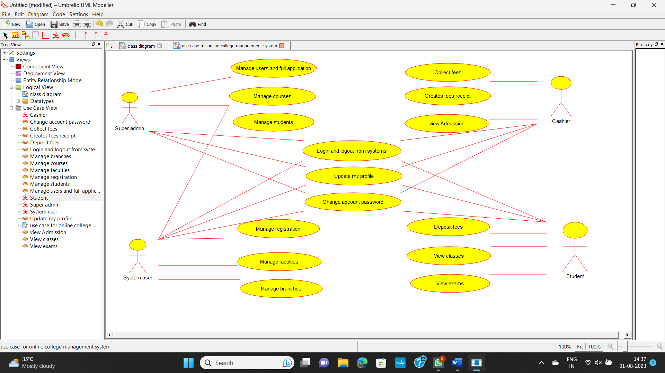

**Experiment 7:** Draw a Use Case diagram for a Restaurant Systems. The activities of the Restaurant system are listed below. Receive the Customer food orders, Produce the customer ordered food, Serve the customer with their ordered food, collect payment from Customers, Store customer payment details, Order Raw Materials for food products, Pay for Raw Materials and Pay for Labour.

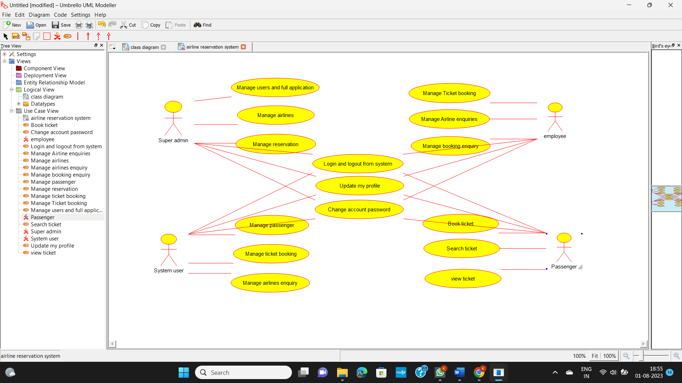

**Experiment 8:** Draw a Use Case diagram for a Restaurant Systems. The activities of the Restaurant system are listed below. Receive the Customer food orders, Produce the customer ordered food, Serve the customer with their ordered food, collect payment from Customers, Store customer payment details, Order Raw Materials for food products, Pay for Raw Materials and Pay for Labour.

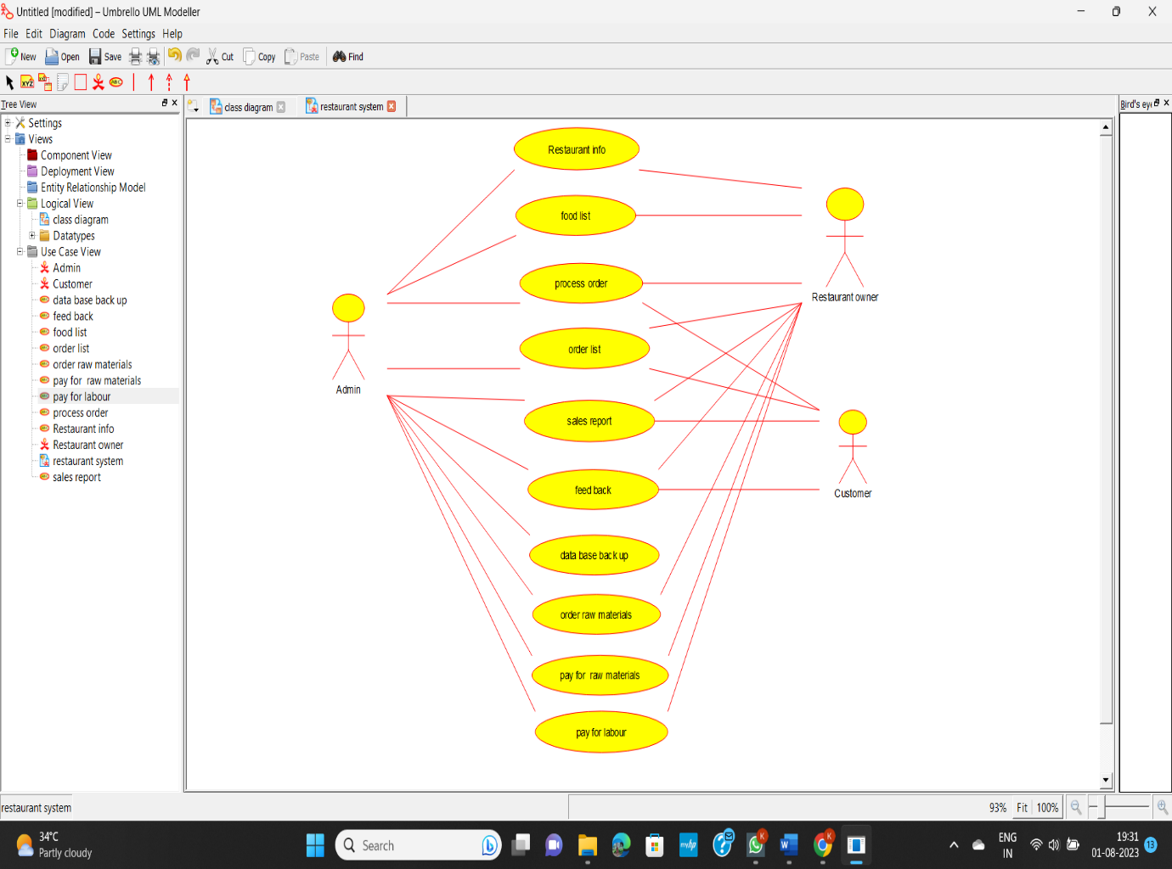

**Experiment 9:** Draw a Use case diagram to model for a quiz system. A user can request a quiz for the system. The system picks a set of questions from its database, and composes them together to make a quiz. It rates the user’s answers and gives hints if the user requests it. In addition to users, we also have helpers who provide questions and hints. And also, administrators who must certify questions to make sure they are not too trivial, and that they are correct

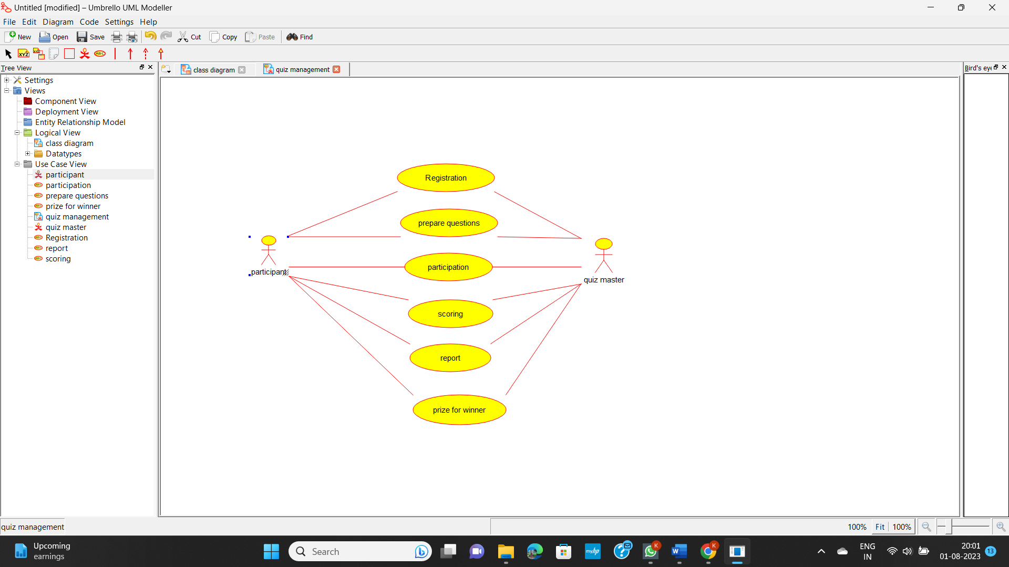

**Experiment 10:** E-wallet is an online prepaid account where one can stock money, to be used when required. As it is a pre-loaded facility, consumers can buy a range of products from airline tickets to grocery without swiping a debit or credit card. You are required to design a similar E Wallet Management System (EMS) using Use case diagram

